Visualization of B-Tree
Andre Sovich, Jenna Olsen, & Maritza Rodriguez
Spring 2025
Adapted from the Fall 2024 Capstone Project

Contents
Project Description 3
Who are the users? 3
What is the main goal? 3
Dependencies 3
Requirements 3
External Design 4
Title Banner 4
Tree Selection 4
Degree Selection 4
Insertion 4
Clear 4
Visualization Window 5
Step Forward 5
Step Back 5
Internal Design 6
Potential Changes and Improvements 6

Project Description
The following project provides an interactive visualization of a B-Tree algorithm. It uses the QT animation widgets to represent the B-Tree node structure. The B-Tree visualization requires dynamic user input to carry on with the demonstration of the self-balancing tree algorithm. Its purpose is to help our users better understand the visual process of what occurs in a B-Tree algorithm, with a small transcript on the side explaining the node movement.

Who are the users?
The users for the project would be students, active learners, or algorithm enthusiasts who want to visually see a representation of a sorting algorithm.

What is the main goal?
The main goal of this project was to refactor and enhance the animation logic for the B-Tree insertion, building on the previous Fall 2024 B-Tree project. The updated animations in the project outline the node relationships by connecting them to their parent or root node based on the maximum degree set. The user can track the node's movement in the B-Tree process by using the step forward and step back buttons in the GUI.

Dependencies
This project uses the QT framework with C++ under the QT educational license.
- QT 6.8.1
- C++ v.13 or higher

Requirements
The code requirements to run the QT visualization are listed below.
- B-Tree algorithm & Main Window
- Insertion
- B-Tree Instruction
- Maximum key
- Clear
- Step back
- Set forward
- Node animation
- Line animation

External Design
The external design layout shown below in Figure 1 was created to visually represent the B-Tree algorithm through interactive buttons for the user. Due to time constraints during the integration of the node animations, not all features shown within the GUI were fully implemented. The interface content that was fully implemented is described below.

Title Banner
The orange banner placed at the top of the GUI is a QLabel widget that displays the title of the visualization project.

Tree Selection
The QRadioButton options labeled “B-Tree”, “B+Tree”, and “B*Tree” in the row below the title banner allow the user to select between different types of B-Tree algorithms.

Degree Selection
The QComoBox labeled “Max Degree=” list degrees values ranging from 3-7 allowing the user to choose the maximum number of children a node can have before rebalancing the B-Tree.

Insertion
A user can enter a valid integer into the QLineEdit text box seen on the top left of the GUI , which will then be inserted into a node upon the user clicking the QPushButton labeled “Insert” .

Clear
The QPushButton labeled “Clear” will clear all the animations that were visible letting the user essentially start over.

Visualization Window
The QFrame visualization located in the middle of the window is where the animation insertion into the B-Tree algorithm will take place. The gray rectangle beside it is represented by QTextEdit, which informs the user of what movement is being made with each new insertion, providing a basic concept of the inner workings of the B-Tree sort.

Step Forward
The “Step Forward" QPushButton allows the user to regenerate the B-Tree nodes from the beginning and step through the insertion process to see how the algorithm was being generated.

Step Back
The “Step Back” QPushButton will revert and step back into the previous node.

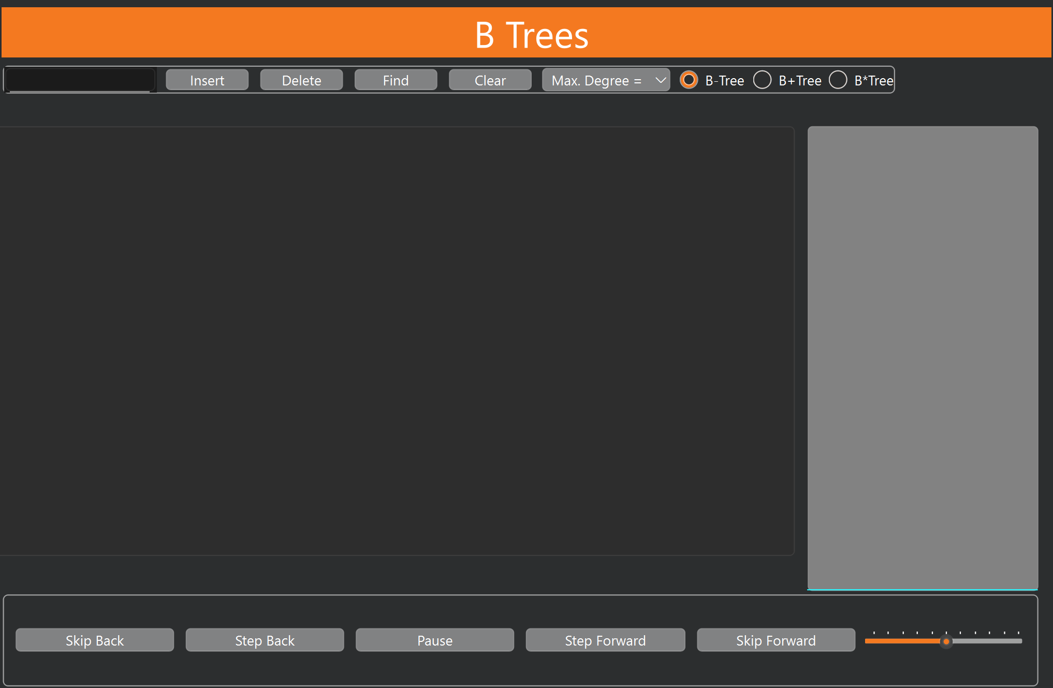
Figure 1

Internal Design
For the internal design, we worked on several git branches to implement our features for the B-Tree visualization. Under the folder called “AnimationTesting” we tested our animation design and then integrated it with the B-Tree visualization folder, mainly using mainwindow.cpp and BTree.cpp to outline the node relationship for the algorithm.

Potential Changes and Improvements
- Integrate animations correctly between the different B-Tree algorithms.
- Update the visualization window to describe the node movements in greater detail.
- Implement the find, delete, skip back, pause, and the animation speed slider.

